|  |  |  |  |  |  |  |
| --- | --- | --- | --- | --- | --- | --- |
| Description: Vertical full colour positive | Safety Bay Senior High School | | | | | |
| **CHEMISTRY UNIT 3 & 4** | | | | | | |
| **Test #5:** | | | | | | |
| **Organic Chemistry** | | | | | | |
|  | | | | | | |
| **NAME:** | | |  | | | |
|  | | |  | | | |
| **Time allowed for this paper** | | | | | | |
| Reading time: | | 5 minutes | | | | |
| Working time: | | 50 minutes | | | | |
|  | | | | | | |
| **Structure of this paper:** | | | | | | |
| Section | | | Number of questions | Marks available | | Marks achieved |
| Section One: Multiple Choice | | | 10 | 10 | |  |
| Section Two: Short Answer | | | 4 | 31 | |  |
|  | | |  | | **Total** | ______ / 37 |

**Section One: Multiple Choice**

Answer all questions by circling the correct option. Only circle one option for each question.

1. A student’s study notes on protein structure included these four unlabelled sketches:

|  |  |
| --- | --- |
|  | H  H  H  N  C  C  O  O  H  R |
|  | **I** |

**II**

Ala

His

Met

Ala

Pro

**III IV**

|  |  |
| --- | --- |
|  |  |
|  |  |

1. Which sketches best represent the primary, secondary and tertiary structure of proteins?

|  |  |  |  |
| --- | --- | --- | --- |
|  | **Primary structure** | **Secondary structure** | **Tertiary structure** |
| (a) | I | II | IV |
| (b) | I | IV | II |
| (c) | III | IV | II |
| (d) | III | II | IV |

1. In response to a pain stimulus, the brain produces small polypeptide molecules called enkephalins. These molecules block the transmission of pain through the central nervous system.

The amino acid sequence in one such compound, methionine enkephalin, is:

Tyr – Gly – Gly – Phe - Met

The number of amine, carboxylic acid and amide (peptide) functional groups in this polypeptide is:

|  |  |  |  |
| --- | --- | --- | --- |
|  | **-NH2** | **-COOH** | **-CONH** |
| (a) | 0 | 0 | 5 |
| (b) | 1 | 1 | 4 |
| (c) | 1 | 1 | 5 |
| (d) | 0 | 2 | 4 |

1. Which one of the following compounds is an α- amino acid?

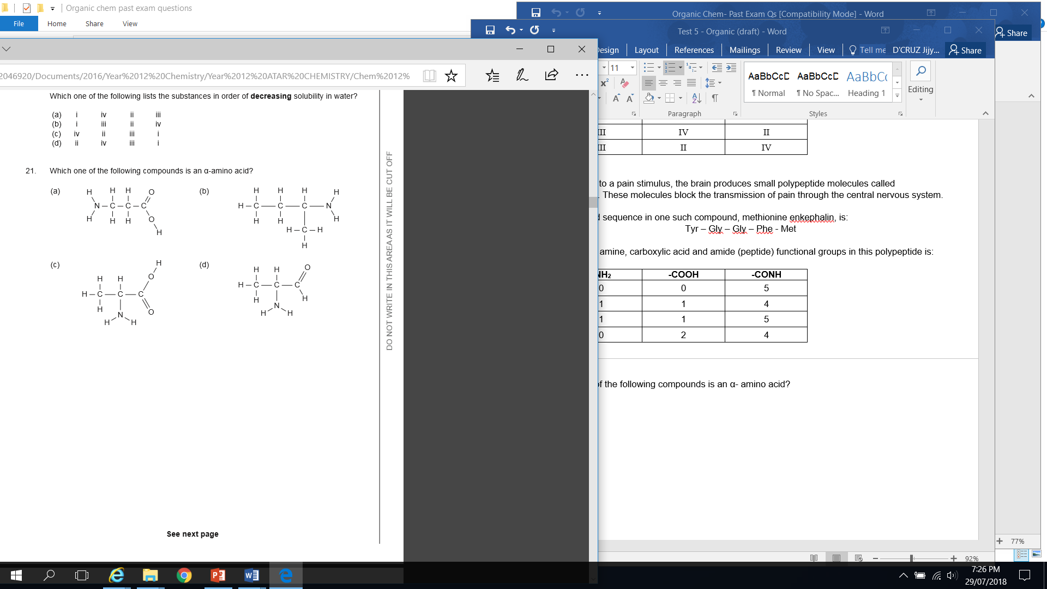

1. Glycine is an amino acid with the formula, H2NCH2COOH. In aqueous solution, glycine forms the glycine zwitterion with the structural formula:

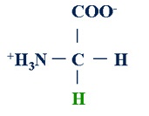

**(Glycine zwitterion)**

The equilibrium reaction of glycine zwitterion in a sealed system at a certain pH is as follows:

**+H3NCH2COO-(aq) + OH-(aq) ⮀ H2NCH2COO-(aq) + H2O(l)**

(glycine zwitterion) (glycinate anion)

The equilibrium concentration of the glycinate anion (**H2NCH2COO**-) can be **increased** by:

1. adding a small amount of water
2. adding a small amount of hydrochloric acid solution

(c) adding a small amount of sodium hydroxide powder

(d) reducing the volume of the sealed system

1. Proteins that show a high degree of similarity in their primary structure in the Protein Data Bank are most likely to have
2. similar function.
3. identical tertiary structure.
4. been isolated from the same species.
5. the same amino acid composition.
6. A chemist attempts to identify a pungent, colourless liquid by conducting several experiments. The results are shown in the table below:

|  |  |
| --- | --- |
| **Experiment** | **Observations** |
| Add acidified potassium dichromate solution | Orange solution turns green |
| A lighted taper held above the liquid | Flame and heat produced |
| Add sodium metal | Metal reacts and colourless, odourless gas evolved |
| Add acidified, concentrated acetic ( ethanoic) acid | Fruity odour produced |

Using this information, identify the functional group present in the liquid.

(a) ketone

(b) alcohol

(c) amine

(d) carboxylic acid

1. 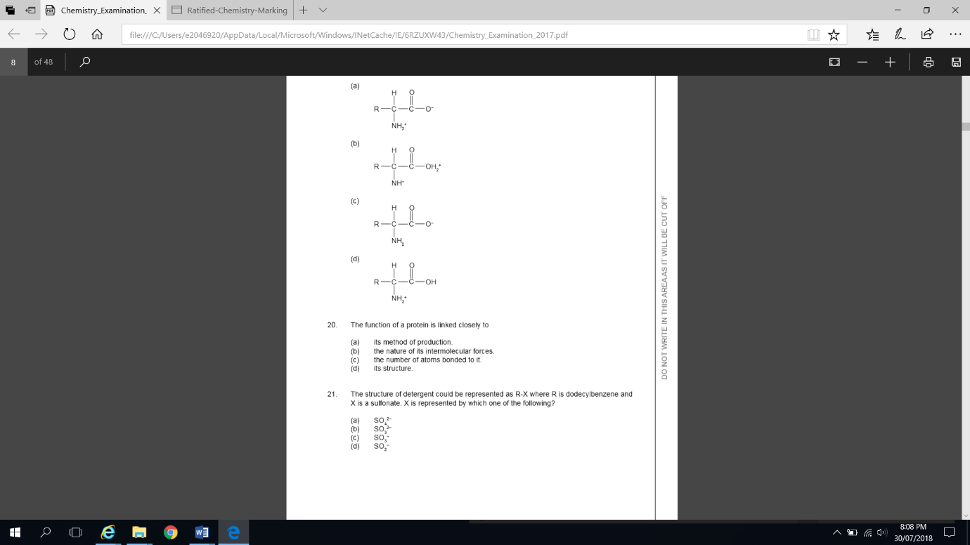Which one of the following structures represents a zwitterion?

1. A compound associated with the smell or flavour of pineapples has the following structural formula

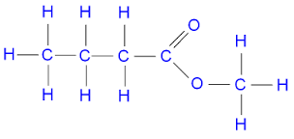

To produce this compound in the laboratory you would react:

(a) methanol and butanoic acid in the presence of concentrated sulfuric acid.

(b) 1-butanol and methanol in the presence of concentrated sulfuric acid.

(c) 1-butanol and methanoic acid in the presence of concentrated sulfuric acid.

(d) methanol and methanoic acid in the presence of concentrated sulfuric acid.

10. For which of the following organic molecules does the structural diagram match the correct IUPAC name given?

|  |  |  |
| --- | --- | --- |
| (i) | (ii) | (iii) |
|  |  |  |
| 2-methylpentan-4-one | 1,2,3-trichloropropene | aminoethanal |

1. (i) only
2. (i) and (ii) only
3. (ii) only
4. (ii) and (iii) only

**Section Two: Short Answer**

Write your answers in the spaces provided.

**Question 7** **(9 marks)**

Phenylalanine (chemical structure shown below) is an essential α-amino acid.

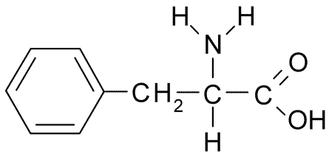

* 1. Why is phenylalanine classified as an **alpha** amino acid? (1 mark)

* 1. In neutral solutions at pH 7, phenylalanine exists as a zwitterion. Draw the structure of the zwitterion form of phenylalanine. (1 mark)

* 1. What evidence is there that solid phenylalanine is comprised of molecules in the zwitterion form? Explain. (3 marks)

* 1. The structure of amino acids is dependent on pH. Draw the structure of the α-amino acid **lysine** under the following pH conditions. *(Refer to your data book for the structure of lysine)* (2 marks)

|  |  |
| --- | --- |
| **pH** | **Structure of lysine** |
| 2 |  |
| 12 |  |

* 1. Draw the structure of a dipeptide formed between phenylalanine and lysine. On your drawing circle and label the ‘peptide bond’. (2 marks)

**Question 8** **(5 marks)**

The following screenshot shows the structure of 5EPZ, a human angiogenin protein.

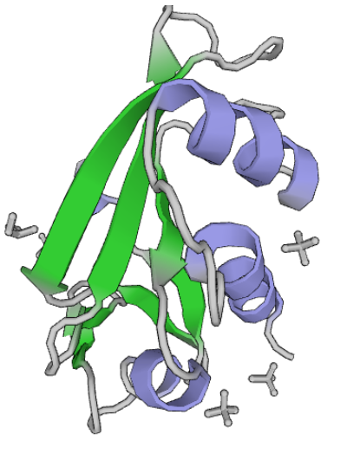

1. Label the above diagram by naming the outlined features. (2 marks)
2. Explain what leads to the formation of the structures shown on the diagram above. (2 marks)

1. The image above was sourced from the Protein Data Bank (PDB). Briefly describe the role of the PDB. (1 mark)

**Question 9** **(6 marks)**

Myrcene is a naturally occurring compound found in the leaves of bay trees. It is known to be a polyunsaturated hydrocarbon. It can react with hydrogen to produce a saturated hydrocarbon.

In a laboratory investigation, a 1.00 g sample of myrcene fully reacted with exactly 510 mL of hydrogen gas measured as 20.0 °C and 105.0 kPa. In this reaction, myrcene was converted to a saturated alkane with a molecular formula C10H22.

* 1. What type of reaction has occurred between the myrcene and hydrogen? (1 mark)

* 1. Calculate the number of moles of hydrogen reacting. (1 mark)

* 1. Calculate the mass of C10H22 produced in the reaction. (2 marks)

* 1. Determine the number of double bonds in each molecule of myrcene. (2 marks)

**Question 10 (11 marks)**

Condensation reactions will take place between different α-amino acids and results in them being joined by peptide bonds. Structures produced by two α-amino acids are called dipeptides, while those produced by three are called tripeptides.

1. Below is the structure of a particular tripeptide.

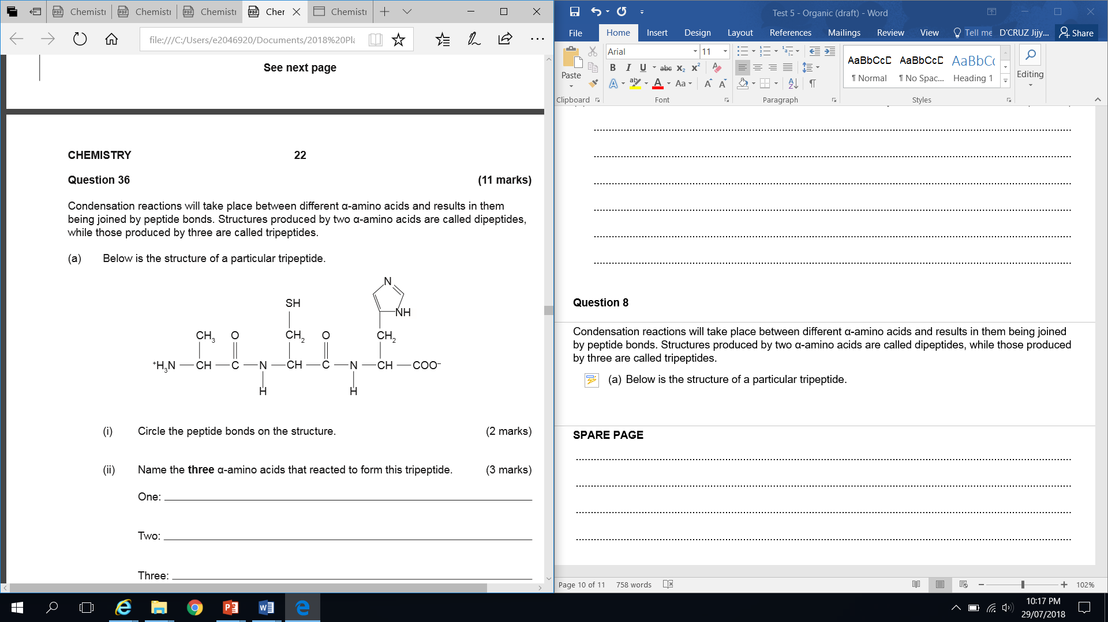

1. Circle the peptide bonds on the structure. (2 marks)

(ii) Name the three α-amino acids that reacted to form this tripeptide. (3 marks)

One:

Two:

Three:

1. Using the symbols (abbreviations) for these three α-amino acids, give one other polypeptide that can be formed from them. (1 mark)

__________________________________________________________________________

Alanine is one of the simplest examples of the twenty α-amino acids found in the human body. The structure below is an isomer of alanine.

1. Circle and name each of the three functional groups on the isomer of alanine drawn below.

(3 marks)

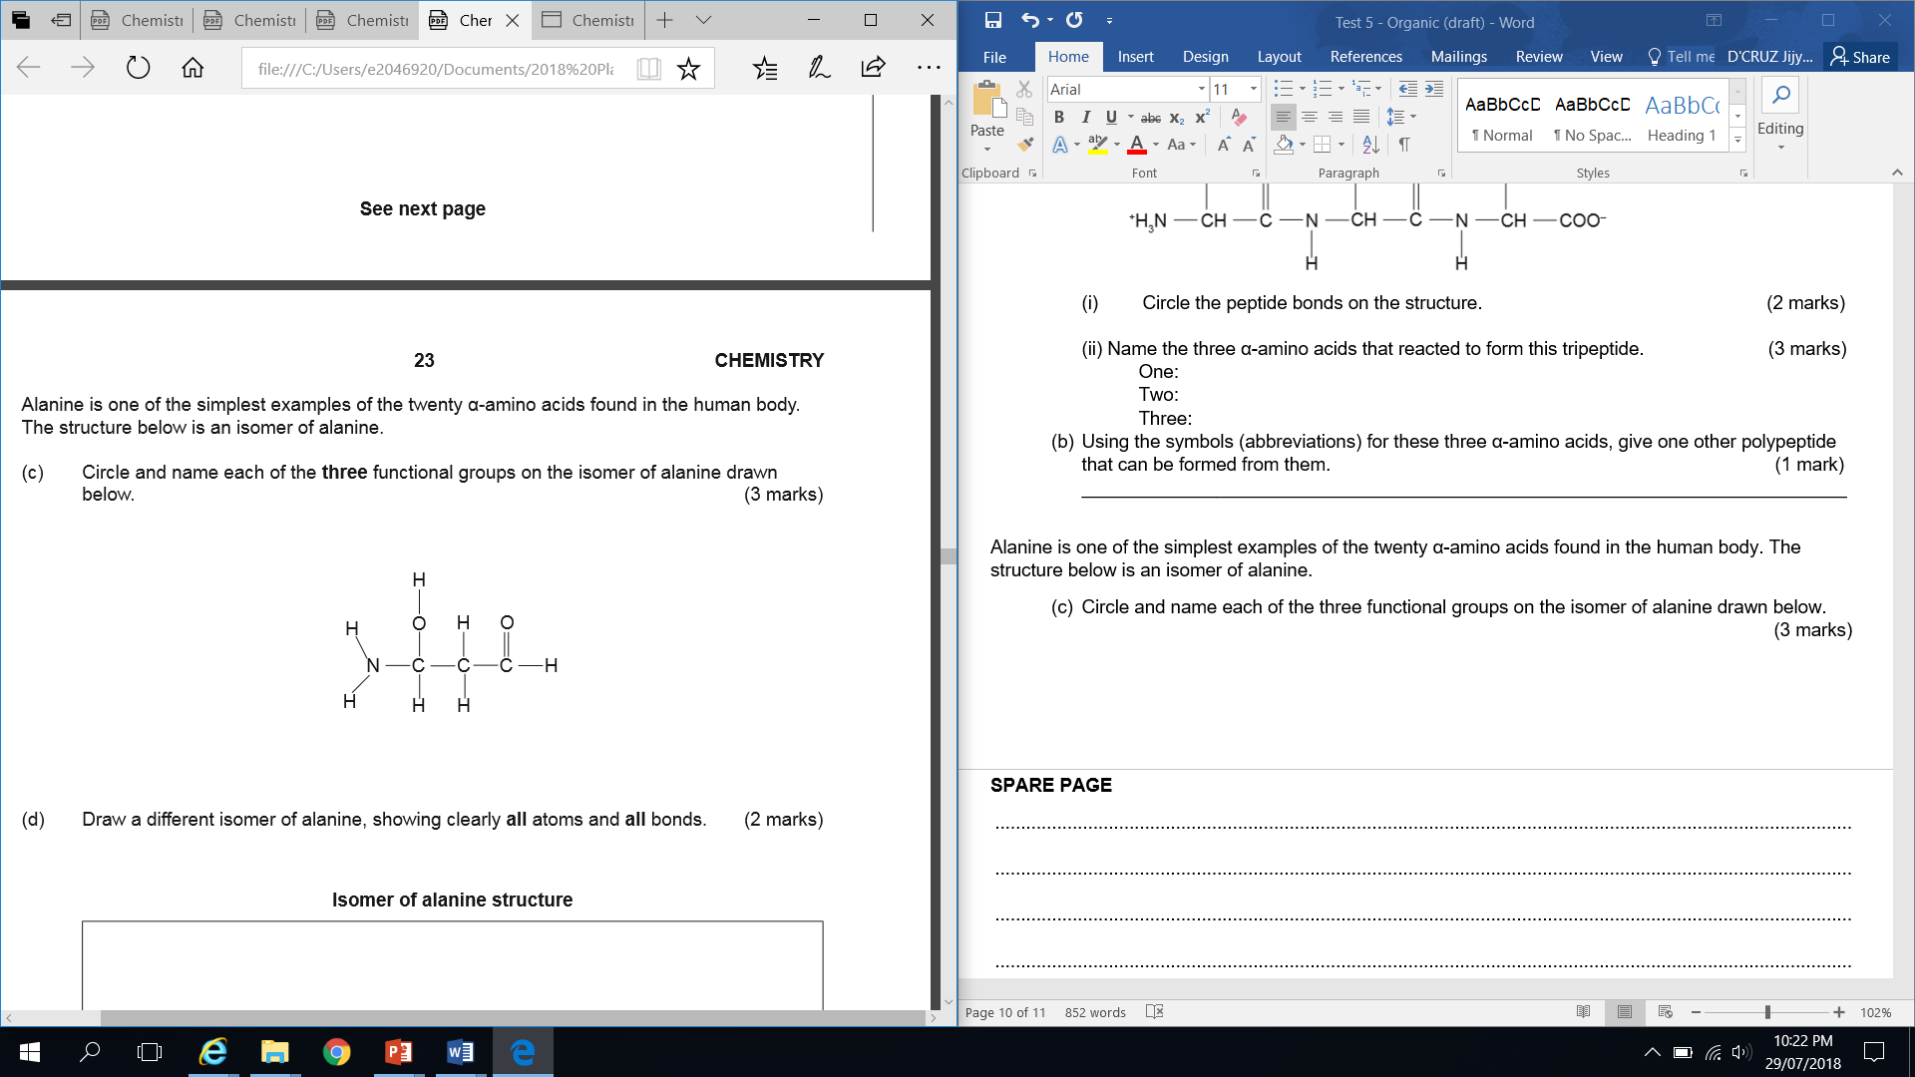

1. Draw a different isomer of alanine, showing clearly all atoms and all bonds. (2 marks)

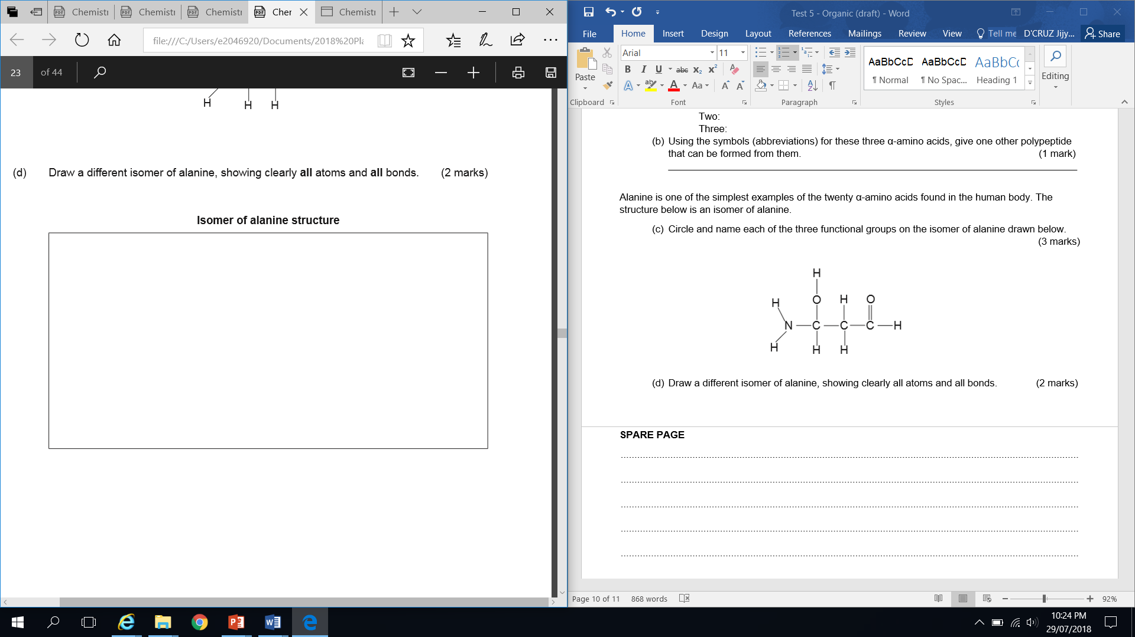

**Question 11 (9 marks)**

Ethanol and methanol are completely miscible (soluble) in water.

1. By referring to any intermolecular forces present, describe the dissolving process as ethanol is added to water. (3 marks)

______________________________________________________________________________________________________________________________________________________________________________________________________________________________________________________________________________________________________________________________________________________________________________________________________________________________________________________________________________

1. Explain what happens to the solubility of alcohols in water as the hydrocarbon chain length increases. (3 marks)

______________________________________________________________________________________________________________________________________________________________________________________________________________________________________________________________________________________________________________________________________________________________________________________________________________________________________________________________________________

1. For each of the following substances, list all force/s of attraction formed between the solute and solvent when each substance dissolves in water. (3 marks)

|  |  |
| --- | --- |
| **Substance** | **Force/s of attraction with water** |
| Propanal |  |
| Methanoic acid |  |
| Sodium Chloride |  |

**SPARE PAGE**